Energy of a photon

Momentum of a photon

Perhaps particles can be thought of as waves with frequency and wavelength

**(1)**

In order for constructive interference to occur the Bragg conditions must be satisfied

**(2)**

The electrons that leave the cathode can have very little kinetic energy, but a potential energy of eV. When they reach the anode, all of this potential energy has been converted into kinetic, so:

which gives the momentum of the electrons and thus the wavelength

Using this result with Eq. 2 gives;

**(3)**

using the small angle approximation gives

**(4)**

The values of d for this calculation are the interatomic separations for the scattering planes in graphite, which may be obtained from Figure 5.

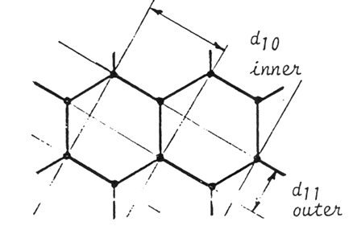

Figure 5 - The graphite crystal structure in the plane of the anode.   
**II. Laboratory Report**

1. In your laboratory report be sure to include a detailed description of how you made your measurement --describe the apparatus and the procedure you used to

make the measurement.

2. You definitely should include a schematic diagram of the experiment as it actually was (i.e. don't count on it being exactly what is in this lab handout.)

3. You should record the experimental procedure you actually used.

4. You should have a table of the values of D at each voltage. Also, you should have a plot of D versus voltage which includes the measured values with error bars as well as the theory predictions of Eq. 3 and 4.

5. You should you should discuss the uncertainties present in your measurement.

**III. Questions to ponder**

1. How can I measure D and L? You may find Appendix B helpful, but how accurate is it?

2. Why are we seeing rings rather than dots at the correct angles given by the Bragg condition?

3. Why are the rings so think? Can I make them sharper? How does this affect the uncertainty in my measurements?

4. How do I know what n is? Why don’t I see lots of rings, one for each n?

5. How do I know Figure 5 is correct?